October 31st, 2010
Hi
Very little to write about. I have been busy writing the additional chapters for the adaptation of the Singapore junior secondary science books for Thailand. At the same time, I have been learning more about the HTML language and my next goal is to reproduce my website page from scratch using this code only rather than using a template. There was not even enough time to read a newspaper and unread Time magazines have been accumulating.
Temperatures have finally dropped a lot in HK. With a maximum of about 23°C expected today, it reminds me that my running season is about to commence. The water in the pool is also cooler but actually good for swimming, rather than just mucking around.
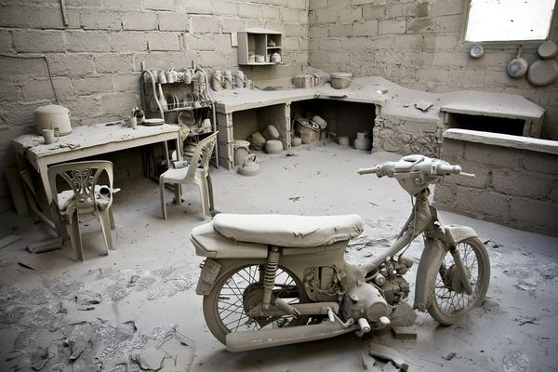
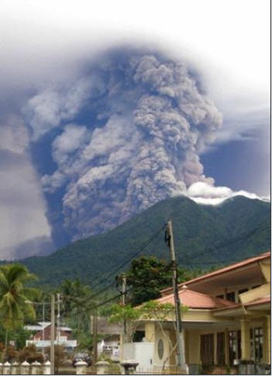
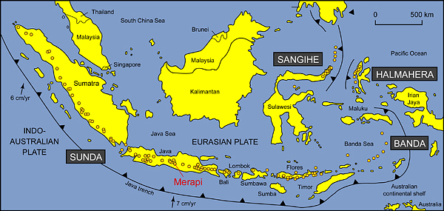
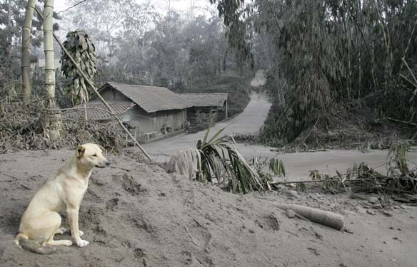
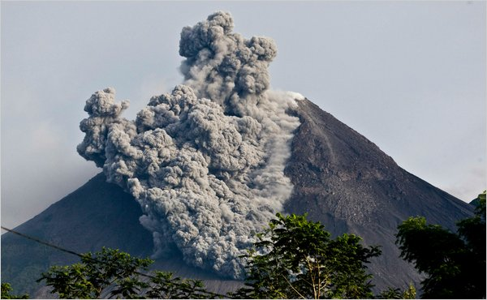
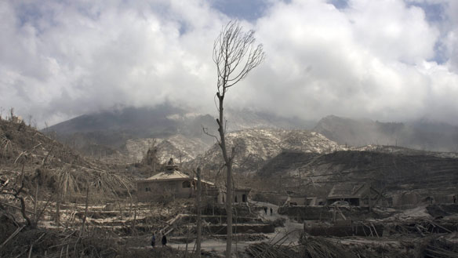
Indonesia was hit this past week not by one, but by two, natural disasters. First there was a 7.7 earthquake just off the coast from Padang (mid-way up the west coast of Sumatra), the city I visited a year or so ago and which itself was nearly destroyed by a big quake about a year ago. This latest quake produced a big tsunami that devastated a chain of islands off the coast from Padang. There was a group of Australian surfers there at the time who had a remarkable tale of survival. When the tsunami hit, they were in two launches off-shore. One launch was propelled by a tsunami wave into the other launch, rupturing its fuel tank and causing an explosion. The people on board had to jump overboard (what a choice!!) and were swept by another wave quite a way inland! Miraculously, they all survived. Then, the day after the earthquake, and 1200 km away in the middle of the island of Java, Mt Merapi (which in English means 'Mountain of fire') erupted. A number of villages were destroyed by ash from the volcano. In both disasters, the human toll was also high. This shows the perils of being in one of the most geologically active parts of the world which is still forming Indonesia, which, in geological terms, is one of the most recent land areas to be formed.


The fourth of the four Bledisloe Cup tests between Australia and NZ was played in HK yesterday. In HK, The Wallabies beat ABs 26-24 with a converted try just after full time (injury time). This was their first win over in the ABs in 11 matches. I had mentioned that there was difficulty selling tickets for the game. Eventually 26 000 were sold out of the 40 000 possible for the stadium.
That’s about it.
Cheers

